MRU / SOE/ CSE/ R-22 / MR22-1CS0141/2023-2024

# Assignment Test- 5

**Subject : DAA/ MR22-1CS0141**

# Submission Dates : 14-12-2023 to 18-12-2023

1. Describe the General method of Branch and Bound and Applications of Branch and Bound.
2. Calculate Travelling Salesperson Problem (TSP) using Branch and Bound.

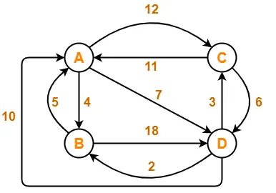

1. Find the optimal solution for the fractional knapsack problem using Branch and Bound technique. Consider n = 5, w = 60 kg

(w1, w2, w3, w4, w5) = (5, 10, 15, 22, 25)

(p1, p2, p3, p4, p5) = (30, 40, 45, 77, 90)

1. Discuss about P- class and NP- class problems with suitable examples.
2. Discuss about Deterministic and Non deterministic algorithms.
3. Explain about NP-Hard and NP-Complete classes.
4. Summarize the NP-Hard problems with suitable examples.